Consumer Perception Survey (CPS)

For Adults

May 19-23, 2025

[Counties/providers may tailor this flyer as needed.]

Tell us what you think about the services you are receiving at this program.

Complete a voluntary and confidential survey.

Choose how you want to participate:

- Secure online survey link for this program:

ADULT
https://uclahs.fyi/CPS2025Adult
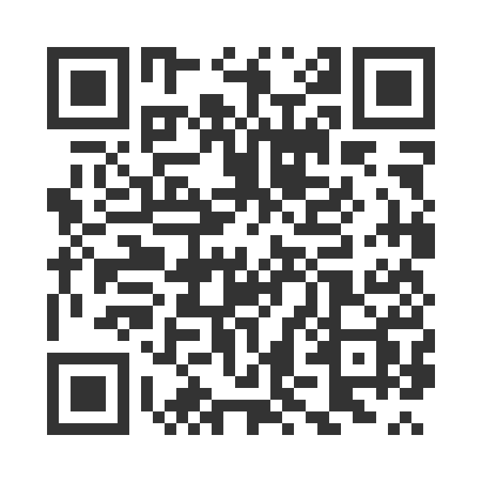

ADULT (+QOL)
https://uclahs.fyi/CPS2025AdultQOL
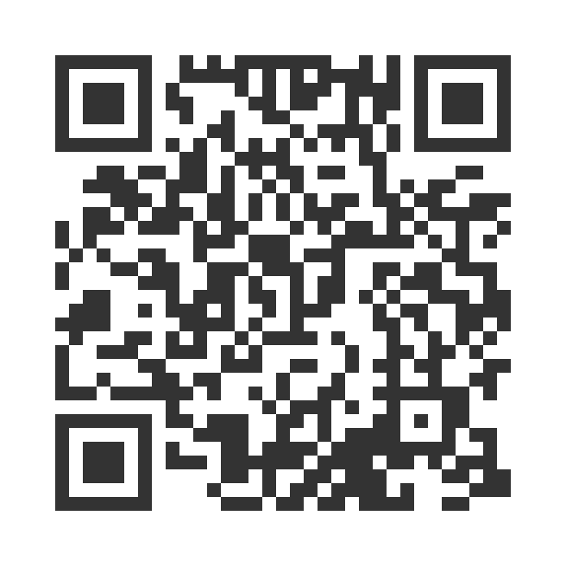

- Paper survey form (ask program staff for a form)

Ask program staff if you have questions or would like assistance with the survey!

Thank you for participating in this important survey!

